**Steps for Implementing Star Topology**

**Step 1: Ta**ke a switch and linked it to six end devices.

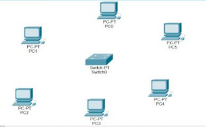

**Step 2:** Link every device with the switch.

**Step 3:** Provide the IP address to each device.

**Step 4:**Transfer message from one device to another and check the Table for Validation.

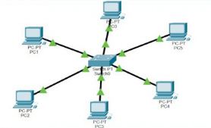

Now to check whether the connections are correct or not, try to ping any device

ping 192.168.1.4

Note: If the connections are correct then you will receive the response.

